**Chapter 5 Homework**

* + What is business process modeling?
    - Is procedure of classifying similar processes into a model
  + But we're writing software, how can we apply business process modeling to our software?
    - Different parts of software use same processes to function and using a process model put that processes in a model
  + What are data flow diagrams?
    - Shows the flow of data
  + How do data flow diagrams connect to business process diagrams?
    - DFD shows a specific flow of data of a business process diagram
  + Are data flow diagrams the same as business process diagrams? Why or why not?
    - Yes but used in a different way
  + How do use cases and data flow diagrams relate to each other?
    - DFDs shows visually how a use cases describes the flow of data
    - 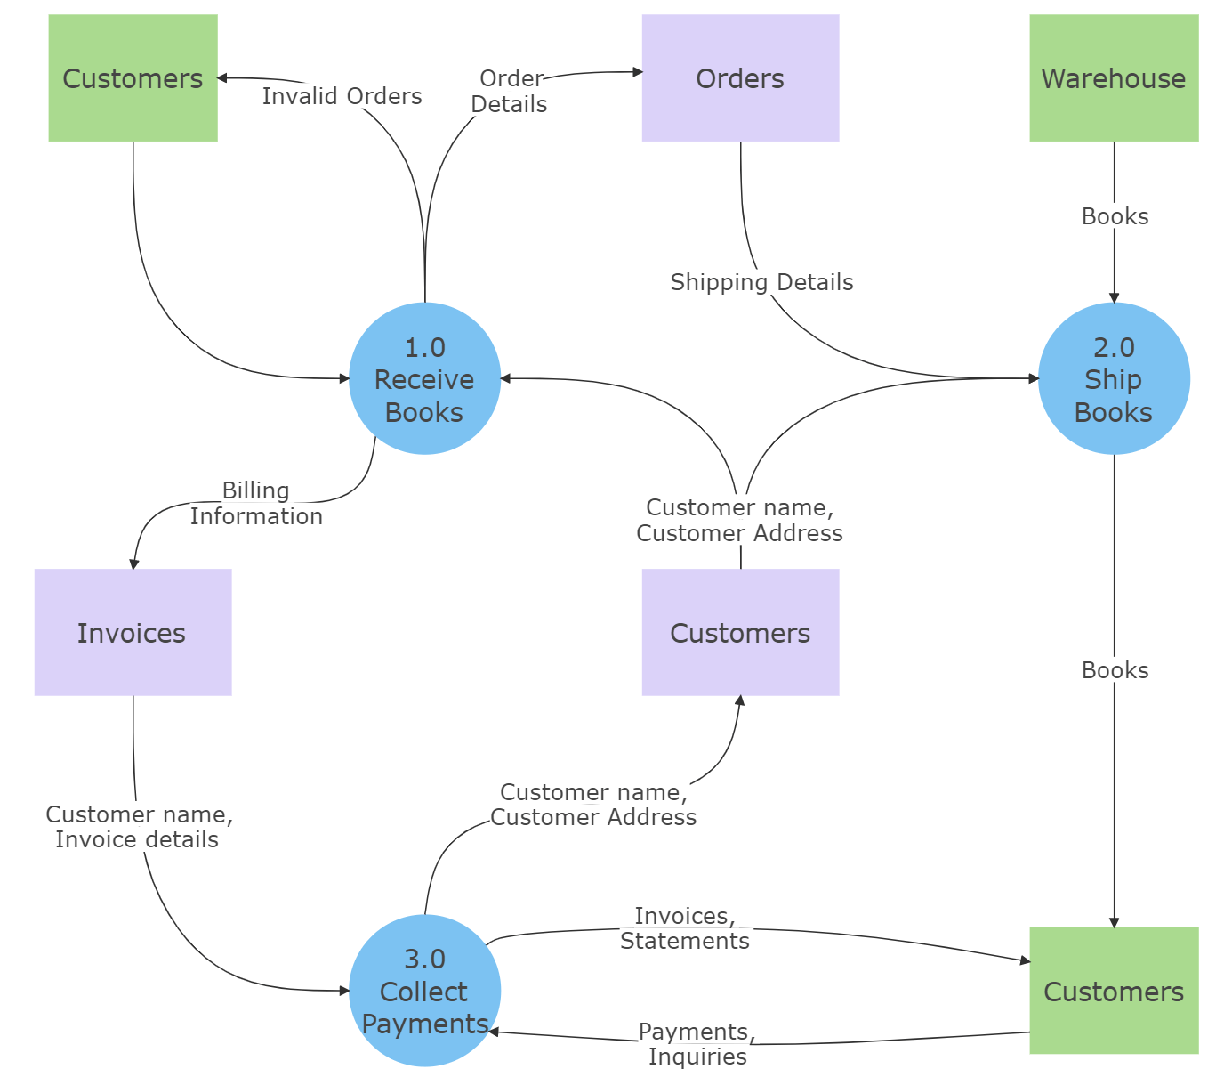Can you find any example business process diagrams or data flow diagrams?
  + Begin thinking through your proposed project. Can you identify any processes or data flows?
    - Data flow of combat encounters